**QGIS WORKSHOP, GRAPHICAL WEB CONFERENCE, 30 August**

**John Walton, @walt_jw**

HOW TO MAKE A HEAT MAP

In this example we are going to replicate this map from the BBC News website on school results in England. http://www.bbc.com/news/education-25762211

2a) First open the shp file “GW_england_counties”. This is a map of England’s counties and local authorities. Go to “Layer” and “Add Vector Layer” and select the shape file.

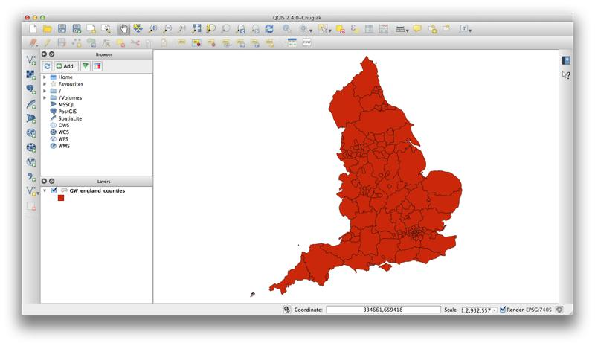

2b) To make a heat map we need to join some data to this set of boundaries. So, open the CSV file “GW_schools” by going to “Layer” and “Add Delimited Text Layer”.

Unlike the previous map, this file contains no x and y data. So, in the “Create a Layer from a Delimited Text File” dialogue select the radio button “No geometry”. Click “OK”.

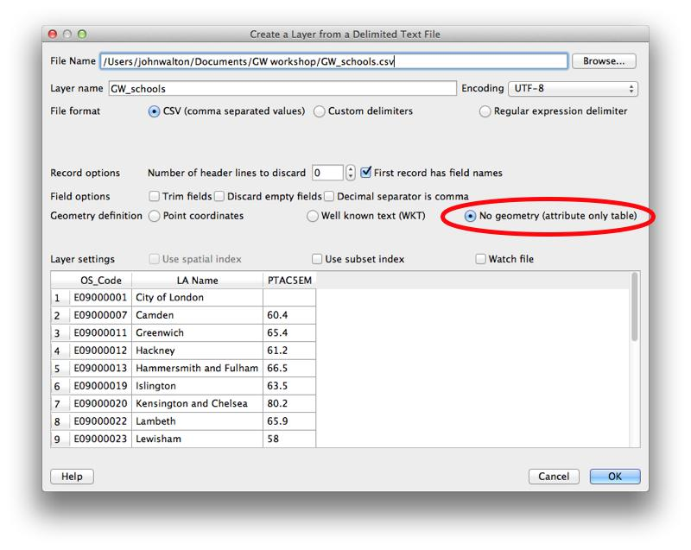

2c) To make our heat map we need to combine the map boundaries with the schools data in the CSV. We do this by making a join between the two files. Select “GW_England_counties” in the “Layer” pane and right click. Select “Properties” and then the “Joins” tab. Next click on the green “+” symbol. A dialogue box “Add Vector Join” will emerge.

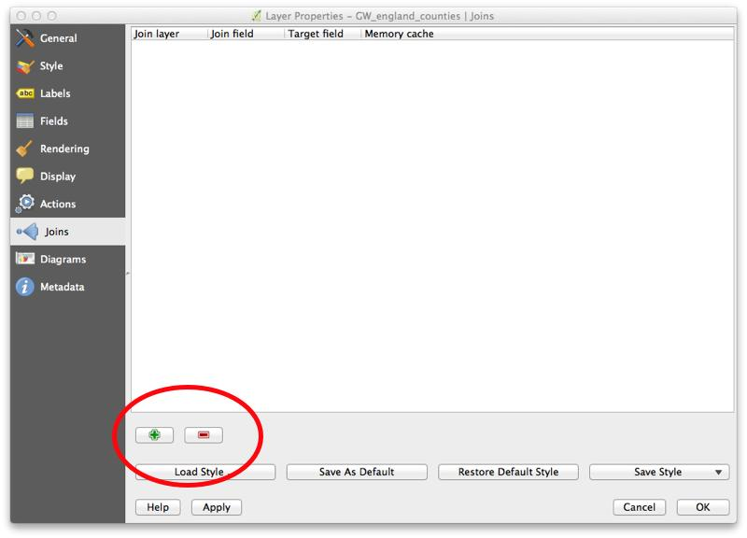

In the…

“Join layer” field choose “GW_schools”

“Join field” field choose “OS_Code”

“Target” field choose “Code”

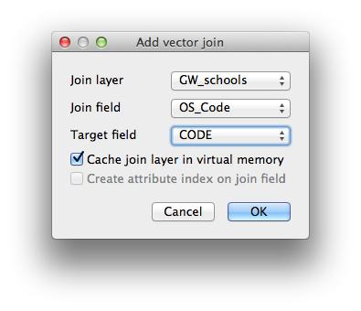

Then click “OK”. And “OK” again, in the next dialogue box.

2d) There are a few steps to setting up the key for the heat map. That all need to doing in this next section.

First, return to the “Properties” tab (by right clicking over the file’s name in the layer pane). This time select “Style”.

1. Change the dropdown menu from “Single Symbol” to “Graduated”. This lets us visualise a set of data with a range of values.

2. Select the column “GW_schools_PTAC5EM” from the “Column” dropdown menu. This tells QGIS that this is the data we are interested in mapping.

3. Set “Classes” to 5, this will give us five different coloured bands for our heat map.

4. In “Mode” select “Quantile (Equal count)” from the dropdown. This will let us see the school data in five equal groups, by number of counties. This should give us an idea of whether or not there is an interesting geographical spread to this story.

5. In the “Colour ramp” select the “Blues”. This will give us a weak blue for low values, highlighting the weaker school test results, and a strong blue for those places that have the highest performing schools.

6. Select “Classify”. This will show you the values that QGIS has selected for each of the five bands we’ve defined with our selections in the “Classify” and “Mode” drop down menus.

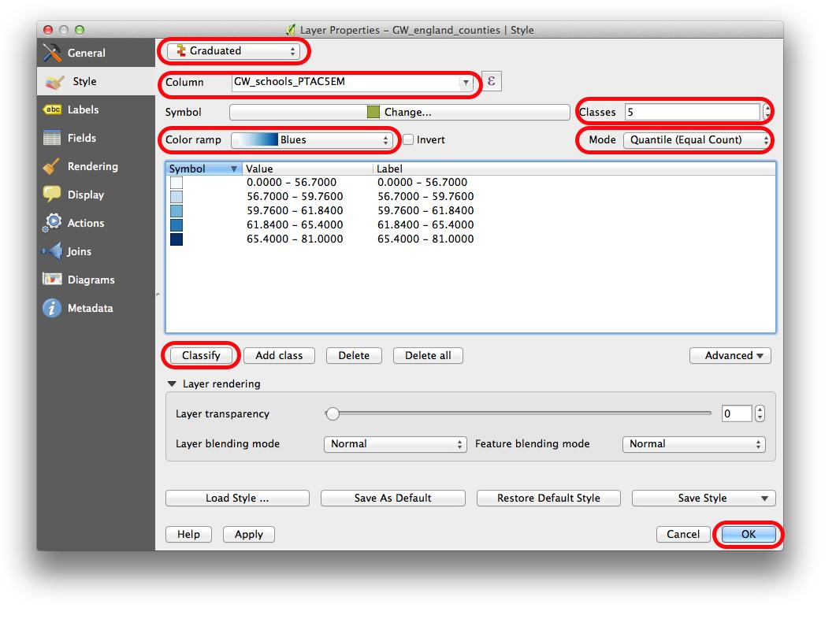

You should then have something like this -

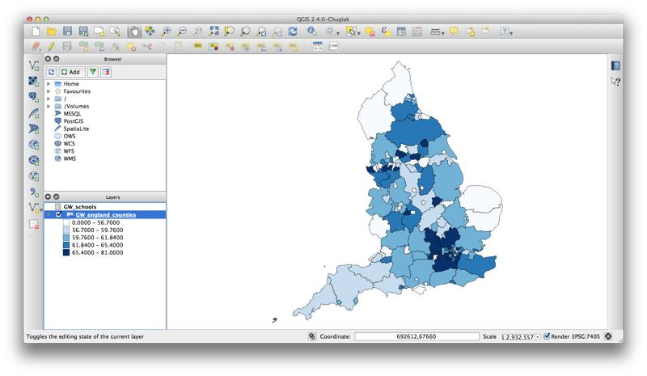

2e) If you would like to manually override the key to the map and enter the data we used for this story then make sure you have five classes and you can enter the data below by clicking on each class in the “Value” section, and entering top and bottom values for that band using the information below.

Once the bands have been set you can manually enter the RGB values for each colour by clicking on the “Symbol” section and then “Colour”, “Select Colour” and then change “Grayscale Sliders” to “RGB Sliders” and enter the RGB values for each band. Again the info is below.

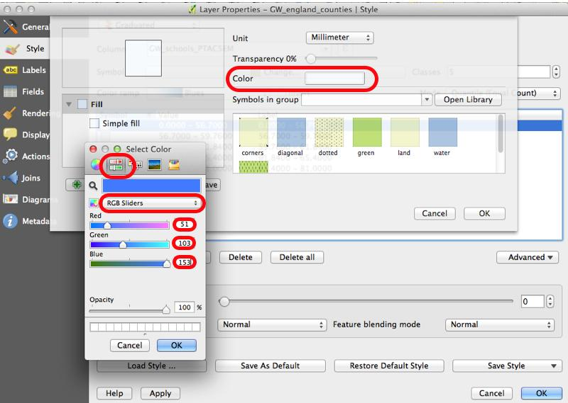

Less than 50% RGB(51,103,153)

50-54% RGB(154,187,206)

55-59.1% RGB(193,211,222)

59.2-64% RGB(255,204,102)

65% and above RGB(246,137,34)

(Bracknell Forest has no data)



